ONLINE ELECTION

SYSTEM

FINAL PROJECT REPORT CSE-326

Team Members:

* Ankush Jassal (11903353)
* Vicky Kumar (11917939)
* Yellow Madhukar (11903309)

Section : K19EG (GRP.1)

Roll Numbers: 13,14,15

PROJECT REPORT SUBMITTED TO :

* Mrs. Nikita Kaushik

Table Of Contents :

Contents Pages

* Abstract 3
* Introduction 4
* Working 5
* Technologies to be used 6
* Significance of study 7
* Objectives of the project 8
* Scope 9
* Modules 10
* Advantages and Disadvantages 11
* Old Methods of Voting 12
* Overall Description 13-14
* Snapshots 14-15
* Summary 16
* Role of Each Member

ABSTRACT

The word “vote” means to choose from a list, to elect or to determine. The main goal of voting (in a scenario involving the citizens of a given country) is to come up with leaders of the people’s choice.

Most countries, Kenya not an exception have problems when it comes to voting. Some of the problems involved include ridging votes during election, insecure or inaccessible polling stations, inadequate polling materials and also inexperienced personnel.

This online voting/polling system seeks to address the above issues. It should be noted that with this system in place, the users, citizens in this case shall be given ample time during the voting period. They shall also be trained on how to vote online before the election time.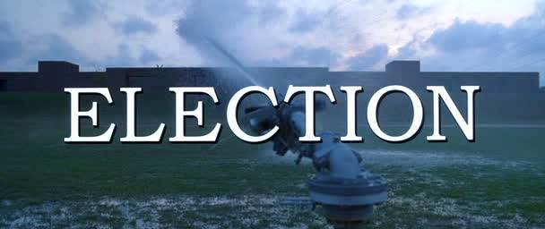





INTRODUCTION

“ONLINE VOTING SYSTEM” is an online voting technique. In this system people who have citizenship of Kenya and whose age is above 18 years of age and any sex can give his\her vote online without going to any physical polling station. There is a database which is maintained in which all the names of voters with complete information is stored.

In “ONLINE VOTING SYSTEM” a voter can use his\her voting right online without any difficulty. He\She has to be registered first for him/her to vote. Registration is mainly done by the system administrator for security reasons. The system Administrator registers the voters on a special site of the system visited by him only by simply filling a registration form to register voter. Citizens seeking registration are expected to contact the system administrator to submit their details. After the validity of them being citizens of India has been confirmed by the system administrator by comparing their details submitted with those in existing databases such as those as the Registrar of Persons, the citizen is then registered as a voter.

After registration, the voter is assigned a secret Voter ID with which he/she can use to log into the system and enjoy services provided by the system such as voting. If invalid/wrong details are submitted, then the citizen is not registered to vote.

Working :

In “ONLINE VOTING SYSTEM” a voter can use his\her voting right online without any difficulty. He\She has to fill a registration form to register himself\herself. All the entries is checked by the DATABASE which has already all information about the voter. If all the entries are correct then a USER ID and PASSWORD is given to the voter, by using that ID and PASSWORD he\she can use his\her vote. If conditions are wrong then that entry will be discarded.

Scope:

The scope of the project that is hosted on the server. There is a DATABASE which is maintained by the ELECTION COMMISION OF INDIA in which all the names of voter with complete information is stored.

Technologies to be Used :

Html **-** Hyper Text Markup Language

CSS **-** Cascading Style Sheets (programming language)

Java Coding- This is for advanced user who find PHP codes easy to work with.

**MYSQL DBMS-** It allows combination, extraction, manipulation and organization of data in the voters’ database. It is platform independent and therefore can be implemented and used across several such as Windows, Linux server and is compatible with various hardware mainframes. It is fast in performance, stable and provides business value at a low cost.

**JAVA CODING-** This is for advanced user who find PHP,CSS,HTML codes easy to work with.

**Testing-** is done via WAMPSERVER .

**Web browsers**: Mozilla Firefox, Google chrome, Opera and Internet Explorer,bing..

**Reporting Tool** i.e. through Data Report

SIGNIFICANCE OF STUDY

The main purpose of the “ ONLINE ELECTION SYSTEM ” is as follows :

* Reduction of the costs incurred by the Kenyan Electrol Commision during voting time in paying the very many clerks employed for the sake of the success of the manual system.
* Check to insure that the members who are registered are the only ones to vote. Cases of the dead people are also minimized.
* ONLINE VOTING SYSTEM will require being very precise or cost cutting to produce an effective election management system.
* Provision of improved voting services to the voters through fast, timely, and convenient voting.
* Therefore crucial points that this ONLINE ELECTION SYSTEM emphasizes on are listed below.

Require less number of staff during the election.

This system is a lot easier to independently moderate the elections and subsequently reinforce its transparency and

Fairness.

Increase the number of voters as individual will find it easier and more convenient to vote, especially those abroad.

Objectives Of The Project

The specific objective of the project include:

* Reviewing the existing /current voting process or approach in INDIA.
* Coming up with an automated voting system / online voting system in INDIA
* Validating the system to ensure that only legible voters are allowed to vote.
* Implementing a an automated /online voting system

Project justification :

The ONLINE VOTING SYSTEM INDIA shall reduce the time spend making long queues at the polling stations during voting . It shall also enable the voters to vote from any part of the globe as explained since this is an online application available on the internet Cases of the vote miscounts shall also be solved since at the backend of the ONLINE VOTING SYSTEM resides a well developed database using mysql that can provide the correct data once it correctly queried. Since the voting process shall be open as early as possible, the voters shall have ample time to decide whom to vote for.

**Scope :**

* **Advanced technology**: It is an advanced technology used now a days. It increases the E knowledge of the users which is very necessary for current generation.
* **Internet:** It is an online facility and hence very useful for the users. Voters can vote from anywhere at any time in India.
* **E-Mails:** ELECTION COMMISION OF INDIA can send the error report to a particular user if he\she entered false information.
* **E-SMS:** People they have not internet connection they can not check the emails or not have email they can be informed by SMS on their mobile. Today many websites provide free SMS to the mobile. ELECTION COMMISION OF INDIA can use these to send any information.

* Easiest way and less Effort : Less effort and less labor intensive , as the primary cost and focus primary on creating , managing , and running a secure web voting portal .

MODULES

* Home page : This page contains the basic information about the ONLINE ELECTION SYSTEM and consist of Admin login , Register for candidate , Register for VoterID,

Candidate Login ,Voter login options.

* Admin login : It will ask login id of user and login password of user for opening.
* Candidate Login : It will ask user id and password for opening and for further process.
* Contact Us: It will show or open the address or mobile number whenever we click on this option.
* Register for VoterID: It will shows these following options to the user to fill :

1. Name
2. Father Name
3. DOB
4. Address
5. E-mail Id
6. Contact

**Advantages:**

* Fast and easy service.
* The online voting system provides a less time consuming .
* It reduces the paper work and makes the work less tedious for ELECTION COMMISION **Definitions of problems.**

**Disadvantages :**

• **Not User Friendly:** The existing system is not user friendly because the retrieval of data is very slow and data is not maintained efficiently.

• **Difficulty in report generating:** We require more calculations to generate the final result so it is generated at the end of the session. And the voter not get a single chance to change his\her vote.

• **Time consuming**: Every work is done manually so we cannot generate report in the middle of the session or as per the requirement because it is very time consuming.

Old Methods of Voting

* Paper based Voting :The voter gets a blank ballot and use a pen or a marker to indicate he want to vote for which candidate .Hand-counted ballots is a time and a labor consuming process, but it is easy to manufacture paper ballots and the ballots can be retained for verifying this type is still the most common way to vote.
* Lever Voting Machine : This is peculiar equipment , and each lever is assigned for a corresponding candidate . The voter pulls the lever to poll for his favourite candidate . This type of voting machine can count up to the ballots automatically because its interface is not user-friendly enough , giving some training to voters is necessary.
* Punch Card : The voters use metallic hole punch to punch hole on the blank ballot. It can count votes automatically .
* Direct recording electronic voting Machine : This type , which is abbreviated to DRE , integrates with keyboards, touchscreen, or buttons for the voter presto poll, some of they lay in the voting records and counting the votes is very quickly in this. But the other DRE without keep voting records are doubted about its accuracy.

**OVERALL DESCRIPTION**

**Goals of proposed system**

1. **Planned approach towards working : -** The working in the organization will be well planned and organized. The data will be stored properly in data stores, which will help in retrieval of information as well as its storage.

2. **Accuracy : -** The level of accuracy in the proposed system will be higher. All operation would be done correctly and it ensures that whatever information is coming from the center is accurate.

3. **Reliability:** - The reliability of the proposed system will be high due to the above stated reasons. The reason for the increased reliability of the system is that now there would be proper storage of information.

4. **No Redundancy: -** In the proposed system utmost care would be that no information is repeated anywhere, in storage or otherwise. This would assure economic use of storage space and consistency in the data stored.

5. **Immediate retrieval of information: -** The main objective of proposed system is to provide for a quick and efficient retrieval of information.

6. **Immediate storage of information: -** In manual system there are many problems to store the largest amount of information.

7. **Easy to Operate : -** The system should be easy to operate and should be such that it can be developed within a short period of time and fit in the limited budget of the user.

SNAPSHOTS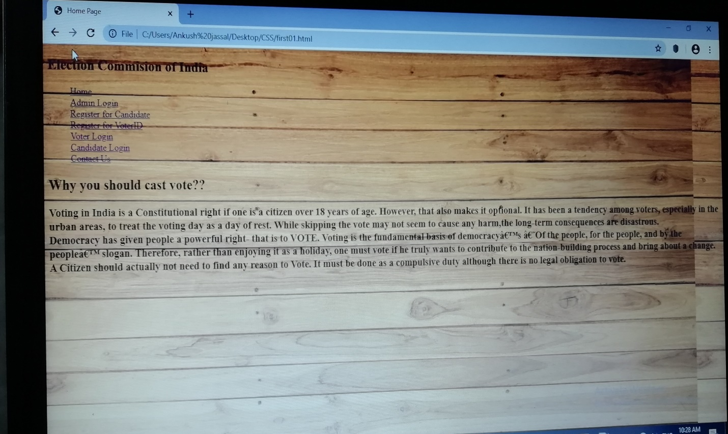



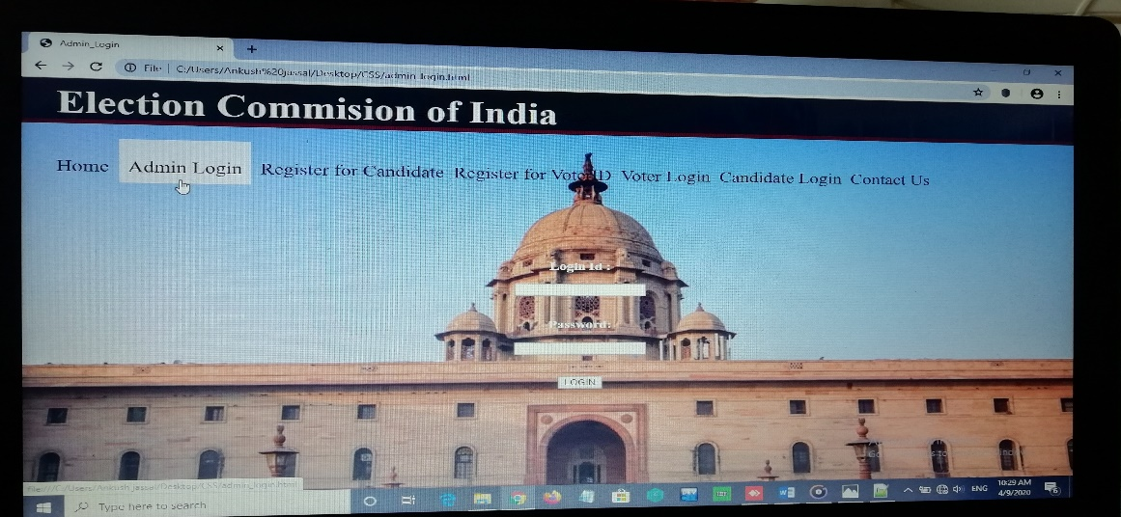

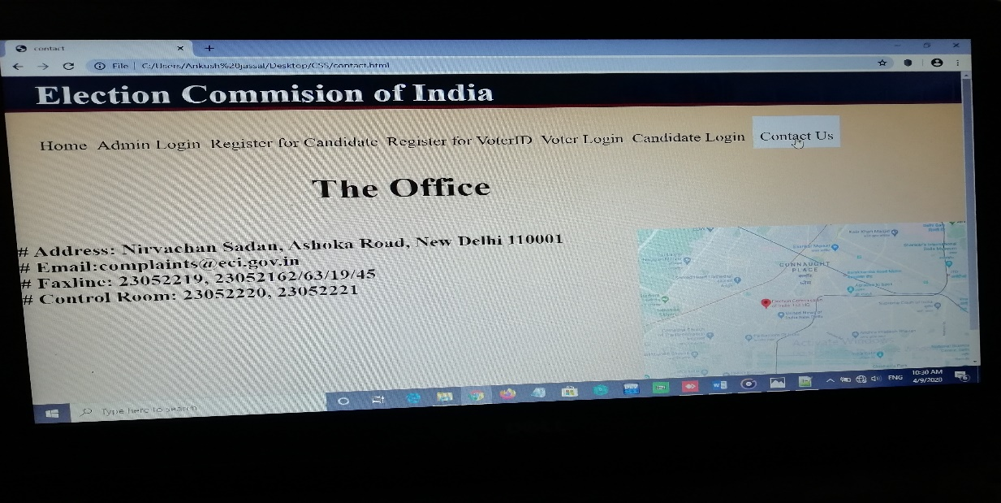

Summary :

* “ONLINE VOTING SYSTEM” is an online voting technique. It is based on the other online services like “ONLINE RESERVATION SYSTEM” .In this system people who have citizenship of INDIA and whose age is above 18 years of any sex can give his\her vote online without going to any polling booth. There is a DATABASE which is maintained by the ELECTION COMMISION OF INDIA in which all the names of voter with complete information is stored.

In “ONLINE VOTING SYSTEM” a voter can use his\her voting right online without any difficulty. He\She has to fill a registration form to register himself\herself. All the entries is checked by the DATABASE which has already all information about the voter. If all the entries are correct then a USER ID and PASSWORD is given to the voter, by using that ID and PASSWORD he\she can use his\her vote. If conditions are wrong then that entry will be discarded.

Role of Each member For Making this project :

Contribution of Vicky Kumar

* For making this project I have studied html ,java and css
* I have made the website/webpage of ONLINE ELECTION SYSTEM by taking help from other team members
* I have suggested how to make project report

Contribution of Ankush Jassal

* For making this project I have learnt html , CSS and little bit java language
* I have made project report in this project.
* I have given idea how to design webpage

Contribution Of Madhukar

* I have made the loom video for this